**A MINI PROJECT REPORT**

**ON**

**“RESALE VALUE PREDICTION FOR CARS”**

Submitted to

SAVITRIBAI PHULE PUNE UNIVERSITY

in completion of

**SKILL DEVELOPMENT LABORATORY**

**(T.E Computer Engineering)**

**BY**

Mr. PRAYAG PADWAL Roll No : 305B039

Mr. RITICK JALALI Roll No : 305B050

Mr. VALLABH GHODKE Roll No : 305B019



Department of Computer Engineering

Sinhgad College of Engineering, Pune-41

**Accredited by NAAC with grade ‘A’**

**YEAR 2020-21**

**CERTIFICATE**



Sinhgad Technical Education Society,

Department of Computer Engineering

Sinhgad College of Engineering, Pune-41

Accredited by NAAC with grade ‘A’



**" RESALE VALUE PREDICTION"**

Submitted to

SAVITRIBAI PHULE PUNE UNIVERSITY

in completion of

**SKILL DEVELOPMENT LABORATORY**

**(T.E Computer Engineering)**

BY

Mr. PRAYAG PADWAL Roll No : 305B039

Mr. RITICK JALALI Roll No : 305B050

Mr. VALLABH GHODKE Roll No : 305B019

Prof. S.SHEIKH Prof. M. P. Wankhade

Internal Guide Head of Dept.

Department of Computer Engineering Department of Computer Engineering

Dr. S.D. Lokhande

Principal

SCOE, Pune

**ACKNOWLEDGEMENT**

Primarily we would like to thank Prof. S.SHEIKH for their guidance and support. They provided us knowledge that we needed to complete this project and helped us to increase our potential. We thank our group members for their contribution and cooperation for making this project. This project was made from support and efforts of our group members so we will thank each one of us.

**ABSTRACT**

Predictive analysis is an important weapon in the arsenal of engineering and here in our application we have used the power of predictive analysis in order to predict the price of used cars. Used vehicles are an important asset but often in today’s world people do not manage to get the correct value for their asset, This mainly takes place if the sellers under account are not aware of the market prices. This also applies to the case of buyers where the buyer ends up paying a value way above the price the asset should be valued at.

In order to take care of this issue we have come up with our application which will help the users to log in to the application and supply some common parameters such as Kilometers driven, Engine, year when the vehicle was purchased and many more, inputting these parameters on the user interface in turn gives the input to the model which has been done , This model has been constructed using Random Forest Regression, which works by constructing decision trees during training time and outputting mean of all the trees during prediction. Our model helps to predict the price of the asset with an accuracy of 90 % thus giving the user a satisfactory and the most realistic price close to market standards hence maintaining the integrity of the asset and also ensuring that both the buyer and the seller are not exploited in any way.

**LIST OF FIGURES**

|  |  |  |  |  |  |
| --- | --- | --- | --- | --- | --- |
| **FIG. NO.** | | **FIGURE NAME** | | **PAGE NO.** | |
| Fig 2.1  Fig 3.1 | | Incremental Model Diagram  Use Case Diagram | | 09  10 | |
| Fig 3.2 | | Data Flow Diagram | | 10 | |
| Fig 3.3.1  Fig 3.3.2  Fig 3.4 | | Sequence Diagram (Price Prediction)  Sequence Diagram (Display Price trends)  Component Diagram | | 11  11  12 | |
| Fig 4.1  Fig 4.2  Fig 4.4.1  Fig 4.4.2  Fig 4.4.3  Fig 4.4.4  Fig 4.4.5 | | Method of Implementation Diagram  Flowchart of Random forest Regression  Home Page  Home Page  Deployment on AWS  AWS EC2 Instance  Result and conclusion  Predicting resale value of the car | | 13  14  15  15  16  16  17  18 | |
|  | |  | |  | |

**CONTENTS**

1. **INTRODUCTION** 
   1. Background And Basics
   2. Problem Statement

1.2.1 Scope Statement

**2**. **PROJECT PLANNING & MANAGEMENT**

2.1 Software and Hardware requirement

2.2 Process Model

**3. ANALYSIS & DESIGN**

3.1 Use-Case Diagrams

3.2 Data Flow Diagram

3.3 Sequence Diagrams

3.4 Component Diagram

**4. IMPLEMENTATION**

4.1 Methodology

4.2 Flowchart

4.3 Gui Design/ Screen Shots

**5. HOSTING ON AMAZON WEB SERVICES**

**6. RESULT AND DISCUSSION**

5.1 Result

5.2 Screenshots

**7. CONCLUSION**

**8. REFERENCES**

1. **INTRODUCTION**

**1.1 Need and origin**

TRUE PRICE’S mission is to revolutionize the way used cars are transacted in India. We endeavor to offer an efficient, reliable and hassle-free transacting experience for used cars, thus providing our users an accurate estimation of their used car taking into consideration the vehicle’s parameters in conjunction with the market standards. Therefore reducing the user’s chances of getting manipulated by dealers and buyers into paying an incorrect amount for their resource.

In India where we have people travelling across cities and regions and along with a lot of people coming in from all across the globe, any such transaction can be made easier where our product would help the seller know the correct value of the car and the buyer would also know how much they should be paying for the asset.

**1.2 Problem Statement**

To provide the end user an accurate price of a used car.

.

**1.3** **Scope Statement**

Predicting the price of used cars according to market standards taking into consideration important parameters of the vehicle such as the number of kilometers driven and the type of engine, year of purchase etc.Our aim is to provide the most accurate price for our users which would enable both the sellers and the buyers make sure that neither of them are at a deficit in the transaction for the asset under account.

**2. PROJECT PLANNING & MANAGEMENT**

## Software and Hardware Requirements

### **Hardware requirements**

* Internet connection
* Minimum i3 processor
* 4GB ram

### **Software requirements**

* Browser
* Anaconda
* IDE sublime text , spyder
* Flask
* Major ML libraries
* CSS
* HTML
* Numpy
* Panda
* Matplotlib
  1. **Process Model**

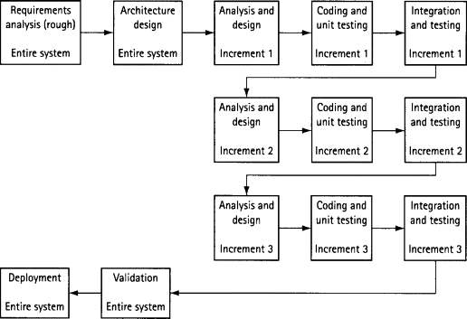

**Fig.2.1**

The incremental build model is a method of software development where the product is designed, implemented and tested incrementally (a little more is added each time) until the product is finished. It involves both development and maintenance. The product is defined as finished when it satisfies all of its requirements. This model combines the elements of the waterfall model with the iterative philosophy of prototyping.

The product is decomposed into a number of components, each of which is designed and built separately (termed as builds). Each component is delivered to the client when it is complete. This allows partial utilization of the product and avoids a long development time. It also avoids a large initial capital outlay and subsequent long waiting period. This model of development also helps ease the traumatic effect of introducing a completely new system all at once.

**3. ANALYSIS AND DESIGN**

## 3.1 Use Case Diagram

Interact with system





Analyze the data



Provide the output



user

system

**Fig. 1. Use Case Diagram**

## 3.2 Data Flow Diagram

**User**

**Dataset**

**SYSTEM**

**Fig. 2. Data Flow Diagram (Level 0)**

## 3.3 Sequence Diagram

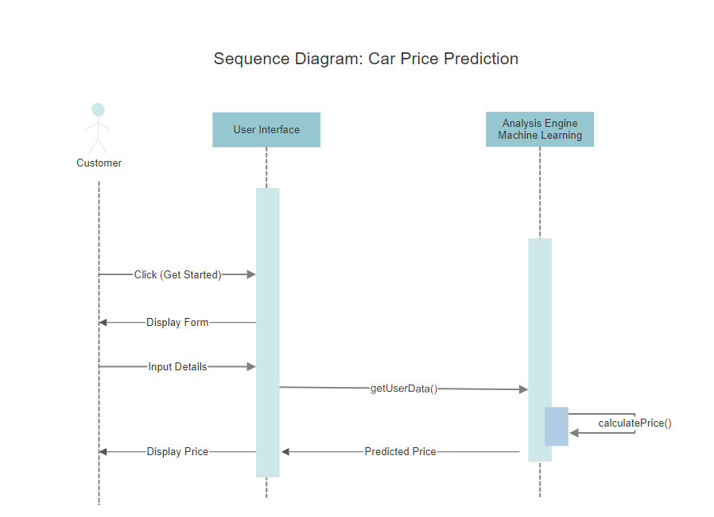

**Fig. 3. Sequence Diagram (Price Prediction)**

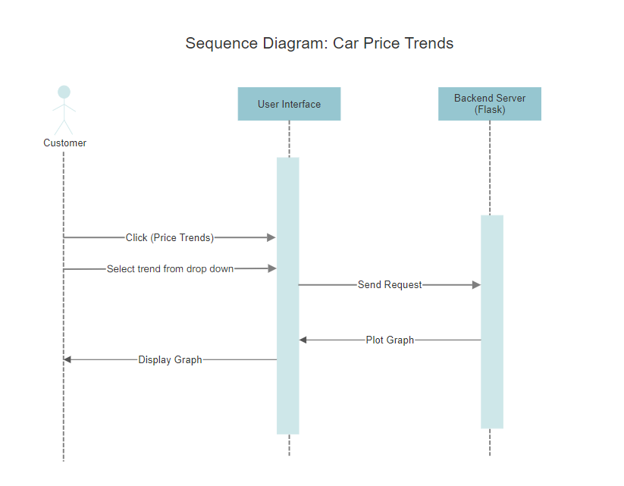

**Fig. 4. Sequence Diagram (Display Price Trends)**

## 3.4 Component Diagram

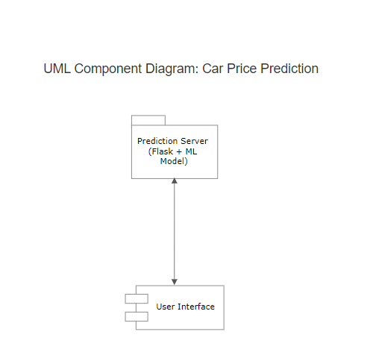

**Fig. 5. Component Diagram**

1. **IMPLEMENTATION**

## Methodology

Collecting the data



Cleaning and Analyzing of the data



Testing and training of the algorithm with data

Taking input

Providing visualization of analysis of existing data

Providing approximate predictions for the given input

## Fig.1. Flowchart

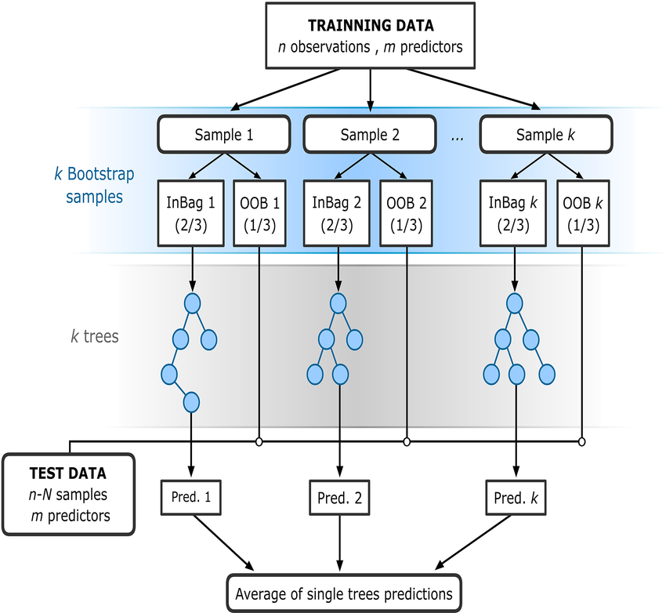we have used Random forest regression which is a supervised learning

algorithm

## Fig.2. Random Forest Prediction Flowchart

* 1. **GUI Design/Screen Shots**

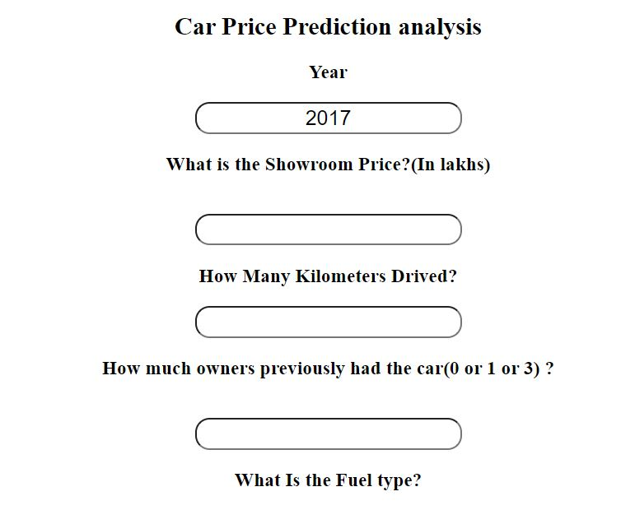

**Fig.1 Home Page**

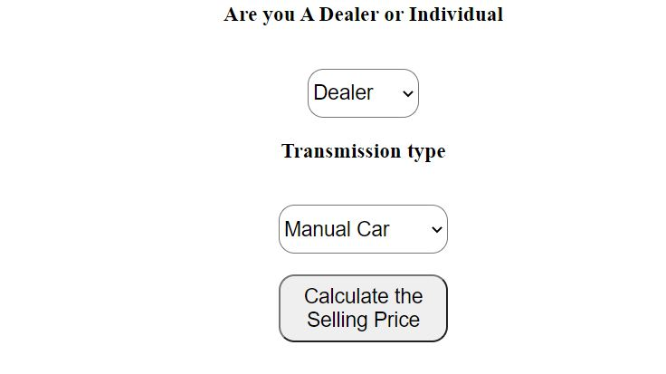

**Fig.2 Home Page**

1. **RESULTS AND DISCUSSION**

Our Application has been able to successfully predict the prices of used cars with an accuracy of 90%.

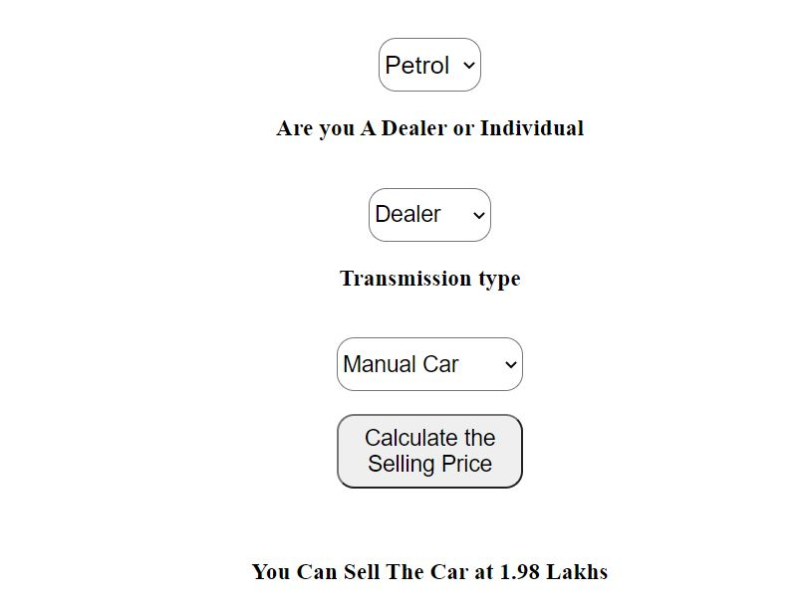

**Fig.5. Predicted Price**

**6. CONCLUSION**

In conclusion, our application would help users to get the best price for their car with an accuracy of 90%. The application would enable it to incorporate many such other applications where with the right kind of data the underlying algorithm would be smart enough to give our users a realistic image of the asset under consideration. Integrating cloud concepts also has been a major entity of our project

**7.REFERENCES**

* https://www.w3schools.com/
* <https://pandas.pydata.org/docs/>
* <https://numpy.org/doc/>
* <https://scikit-learn.org/stable/modules/generated/sklearn.ensemble.RandomForestRegressor.html>
* Python for data analysis by Wes Mckiney
* Great learning .com for data science
* Prepbytes webinar on ML
* AWS ec2 by Stephanne Mareek